Final QA Project

Submitted by: Shrishti Yadav

(Fynd QA Batch 06)

**USER STORY 0001:** Add “**About us**” link option in footer of the application.

**Scenario 1: verify that “About us” link is available and displayed.**

|  |  |  |  |  |
| --- | --- | --- | --- | --- |
| **Sr.No** | **Test Case** | **Expected Result** | **Test Data** | **Test Status** |
| 1 | Launch the application | Application launched successfully | [**https://test-nf.com/english.html**](https://test-nf.com/english.html) | Pass |
| 2 |  |  |  |  |

**Scenario 2: verify position of link.**

|  |  |  |  |  |
| --- | --- | --- | --- | --- |
| **Sr. No** | **Test Case** | **Expected Result** | **Test Data** | **Test Status** |
| 1 | Launch the application | Application launched successfully | [**https://test-nf.com/english.html**](https://test-nf.com/english.html) | Pass |
| 2 | Position of link | Link is always displayed in the footer of application |  | pass |

**Scenario 3: verify that link is highlighted.**

|  |  |  |  |  |
| --- | --- | --- | --- | --- |
| **Sr.No** | **Test Case** | **Expected Result** | **Test Data** | **Test Status** |
| 1 | Launch the application | Application launched successfully | [**https://test-nf.com/english.html**](https://test-nf.com/english.html) | Pass |
| 2 | Position of link | Link is always displayed in the footer of application |  | Pass |
| 3 | Check colour of link text | Link text is always highlighted with blue colour and has underline |  | pass |

**Scenario 4: verify that link is clickable.**

|  |  |  |  |  |
| --- | --- | --- | --- | --- |
| **Sr.No** | **Test Case** | **Expected Result** | **Test Data** | **Test Status** |
| 1 | Launch the application | Application launched successfully | [**https://test-nf.com/english.html**](https://test-nf.com/english.html) | Pass |
| 2 | Position of link | Link is always displayed in the footer of application |  | Pass |
| 3 | Click on the link | User is able to click on link |  | pass |

**Scenario 5: verify that on clicking on “About us” link it is directing to new page.**

|  |  |  |  |  |
| --- | --- | --- | --- | --- |
| **Sr.No** | **Test Case** | **Expected Result** | **Test Data** | **Test Status** |
| 1 | Launch the application | Application launched successfully | [**https://test-nf.com/english.html**](https://test-nf.com/english.html) | Pass |
| 2 | Position of link | Link is always displayed in the footer of application |  | Pass |
| 3 | Click on the link | On clicking on link user id directed to new page. |  | pass |

**Scenario 6: verify that on clicking on “About us” link new page opened is showing organization vision and mission.**

|  |  |  |  |  |
| --- | --- | --- | --- | --- |
| **Sr.No** | **Test Case** | **Expected Result** | **Test Data** | **Test Status** |
| 1 | Launch the application | Application launched successfully | [**https://test-nf.com/english.html**](https://test-nf.com/english.html) | Pass |
| 2 | Position of link | Link is always displayed in the footer of application |  | Pass |
| 3 | Click on the link | On clicking on link user id directed to new page. |  | Pass |
| 4 | Check new page data | New page is displaying organization vision and mission |  | fail |

**Scenario 7: verify that “About us” link is available for all the tabs present in application.**

|  |  |  |  |  |
| --- | --- | --- | --- | --- |
| **Sr.No** | **Test Case** | **Expected Result** | **Test Data** | **Test Status** |
| 1 | Launch the application | Application launched successfully | [**https://test-nf.com/english.html**](https://test-nf.com/english.html) | Pass |
| 2 | Open all the tabs in application one by one and check that about us link is present in footer | “About us” link is available in footer for all the tabs |  | Pass |

**Bugs**

|  |  |  |  |
| --- | --- | --- | --- |
| **Sr.no** | **Bugs** | **priority** | **Severity** |
| 1 | Layout of players image is not uniform | P4 | S3 |
| 2 | Image of Lionel Messi is not correct | P2 | S1 |
| 3 | Spellings of basketball and cybersports is not correct | P3 | S3 |
| 4 | Ads are overlapping navigation bar and learn more text of Lionel Messi | P3 | S3 |
| 5 | Learn more text of Michel Jordan is not displayed | P2 | S2 |
| 6 | The cross hamburger of ads is not clickable | P3 | S2 |
| 7 | On hovering to basketball tab, the text basketball gets disappeared | P2 | S2 |
| 8 | On hovering on football tab, the padding is not proper | P3 | S4 |
| 9 | On opening tabs in navigation bar either the images of sports are not correct or not displaying | P1 | S1 |
| 10 | The texts in sports tab are fading at the end and not displayed properly | P1 | S1 |
| 11 | On clicking on About us and contact us link the page opening is showing error | P1 | S1 |
| 12 | The social media account in footer are not clickable | P1 | S1 |
| 13 | On clicking on “click here” in ad is opening home page | P2 | S2 |

**Selenium Assignment**

**Folder structure**

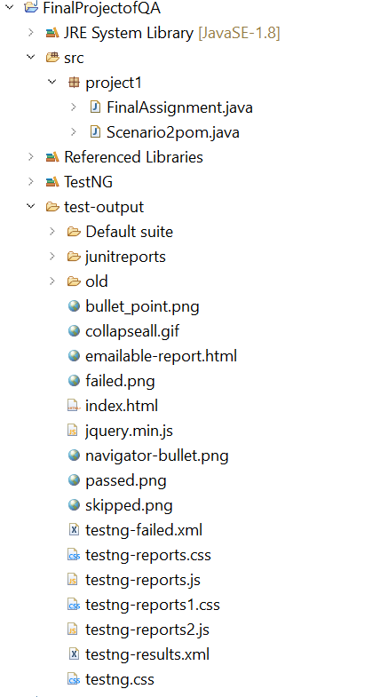

package project1;

import org.openqa.selenium.WebElement;

import org.openqa.selenium.support.FindBy;

public class Scenario2pom {

//creating page object model

@FindBy(xpath = "/html/body/header/div/ul/li[1]/a")WebElement home;

@FindBy(xpath = "/html/body/header/div/ul/li[2]/a")WebElement football;

@FindBy(xpath = "/html/body/header/div/ul/li[3]/a")WebElement basketball;

@FindBy(xpath = "/html/body/header/div/ul/li[4]/a")WebElement cricket;

@FindBy(xpath = "/html/body/header/div/ul/li[5]/a")WebElement cybersports;

}

**Source path of Browser Driver and Link URL of the website**

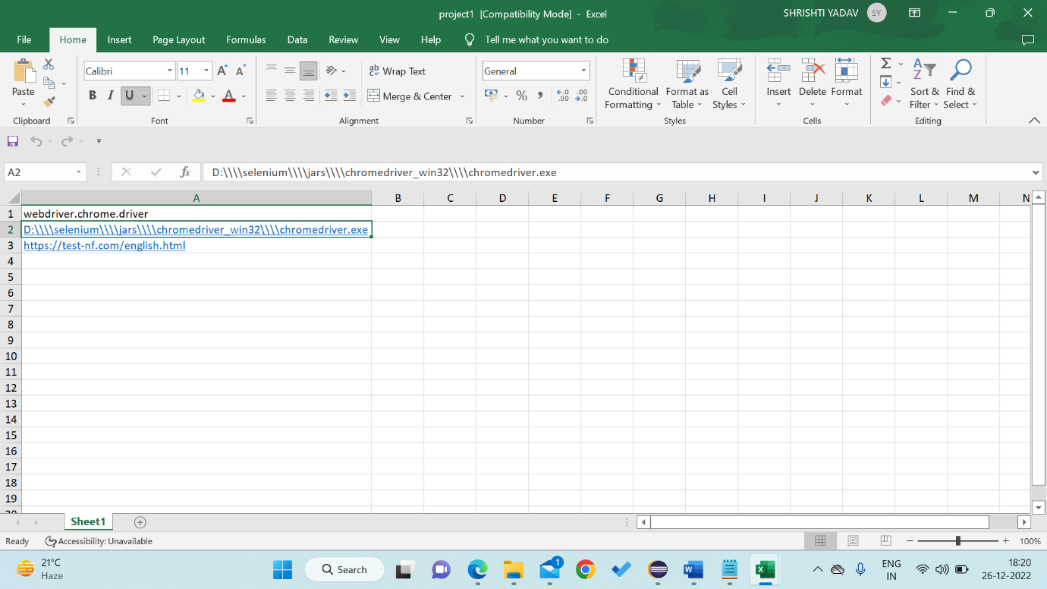

package project1;

import java.io.FileInputStream;

import java.io.FileOutputStream;

import org.openqa.selenium.WebDriver;

import org.openqa.selenium.chrome.ChromeDriver;

import org.openqa.selenium.support.PageFactory;

import org.testng.annotations.AfterMethod;

import org.testng.annotations.BeforeMethod;

import org.testng.annotations.Test;

import org.testng.asserts.SoftAssert;

import jxl.Sheet;

import jxl.Workbook;

import jxl.write.WritableSheet;

import jxl.write.WritableWorkbook;

public class FinalAssignment {

// Declaring WebDriver as public to access it.

public WebDriver driver;

@BeforeMethod

public void launch() throws Exception {

// Used Data Drive method to pass the Data through Excel.

FileInputStream f = new FileInputStream("C:\\Users\\Shrishti\\OneDrive\\Desktop\\project1.xls");

Workbook wb = Workbook.getWorkbook(f);

Sheet sh = wb.getSheet("Sheet1");

System.setProperty(sh.getCell(0, 0).getContents(), sh.getCell(0,1).getContents());

driver = new ChromeDriver();

driver.get(sh.getCell(0, 2).getContents());

}

@Test

public void Execute() throws Exception {

// Imported the Page Object method by Page Factory property. Scenario2pom P = PageFactory.initElements(driver, Scenario2pom .class);

//scenario2. Verify the availability of each tab(Home, Cricket, Football, Basketball and Ciber Sports)

// Use of soft assertion.

SoftAssert sAssert = new SoftAssert();

boolean a = P.home.isDisplayed();

sAssert.assertEquals(a, true);

System.***out***.println("Home tab is available");

boolean b = P.football.isDisplayed();

sAssert.assertEquals(b, true);

System.***out***.println("Football tab is available");

boolean c = P.basketball.isDisplayed();

sAssert.assertEquals(c, true);

System.***out***.println("Basketball tab is available");

boolean d = P.cricket.isDisplayed();

sAssert.assertEquals(d, true);

System.***out***.println("Cricket tab is available");

boolean e = P.cybersports.isDisplayed();

sAssert.assertEquals(e, true);

System.***out***.println("Cybersports tab is available");

//scenario3. Verify URL of each tab contains the tab name. String u = driver.getCurrentUrl();

boolean q = u.contains("english");

sAssert.assertEquals(q, true);

System.***out***.println(" URL contains the tab name");

P.football.click();

String v = driver.getCurrentUrl();

boolean r = v.contains("football");

sAssert.assertEquals(r, true);

System.***out***.println(" URL contains the tab name");

P.basketball.click();

String w = driver.getCurrentUrl();

boolean s = w.contains("busketball");

sAssert.assertEquals(s, true);

System.***out***.println(" URL contains the tab name");

P.cricket.click();

String x = driver.getCurrentUrl();

boolean t = x.contains("kriket");

sAssert.assertEquals(t, true);

System.***out***.println(" URL contains the tab name");

P.cybersports.click();

String y = driver.getCurrentUrl();

boolean j = y.contains("cibersport");

sAssert.assertEquals(j, true);

System.***out***.println(" URL contains the tab name");

// scenario4. Store all the current URL in excel sheet

FileOutputStream i= new FileOutputStream("C:\\Users\\Shrishti\\OneDrive\\Desktop\\result.xls");

WritableWorkbook ww = Workbook.createWorkbook(i);

WritableSheet WS = ww.createSheet("output", 3);

jxl. write.Label l = new jxl.write.Label(0, 0, u);

jxl.write.Label l1 = new jxl.write.Label(0, 1, v);

jxl.write.Label l2 = new jxl.write.Label(0, 2, w);

jxl.write.Label l3 = new jxl.write.Label(0, 3, x);

jxl.write.Label l4 = new jxl.write.Label(0, 4, y);

//Adding the Label value in the cell.

WS.addCell(l);

WS.addCell(l1);

WS.addCell(l2);

WS.addCell(l3);

WS.addCell(l4);

//Saving and closing the workbook..

ww.write();

System.***out***.println("Data is written successfully on ExcelSheet");

ww.close();

}

//closing the application

@AfterMethod

public void Terminate() {

driver.close();

}

}

**output**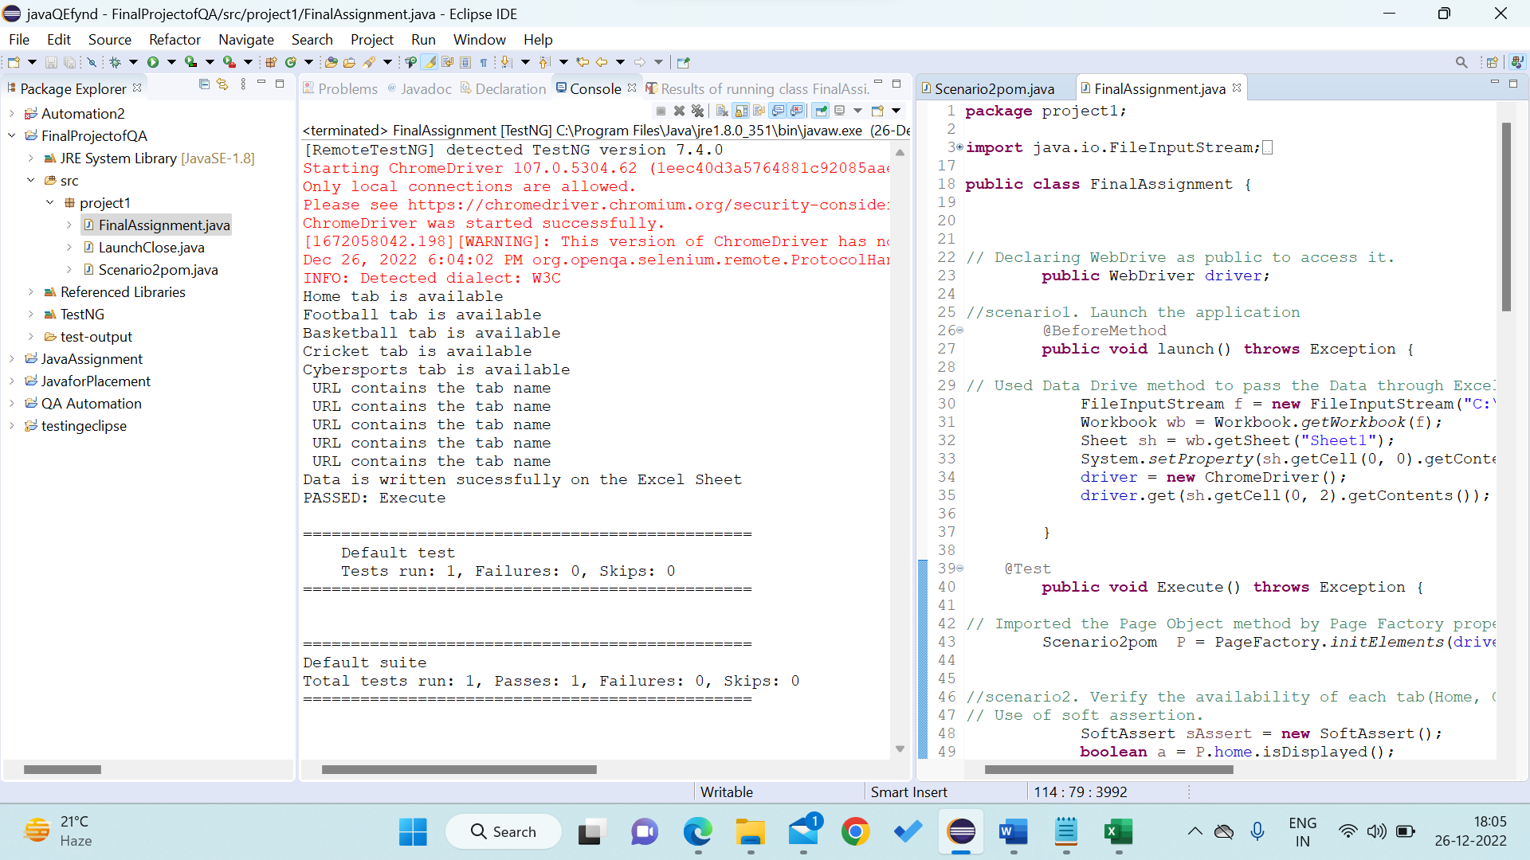

**TEST Ng Report**

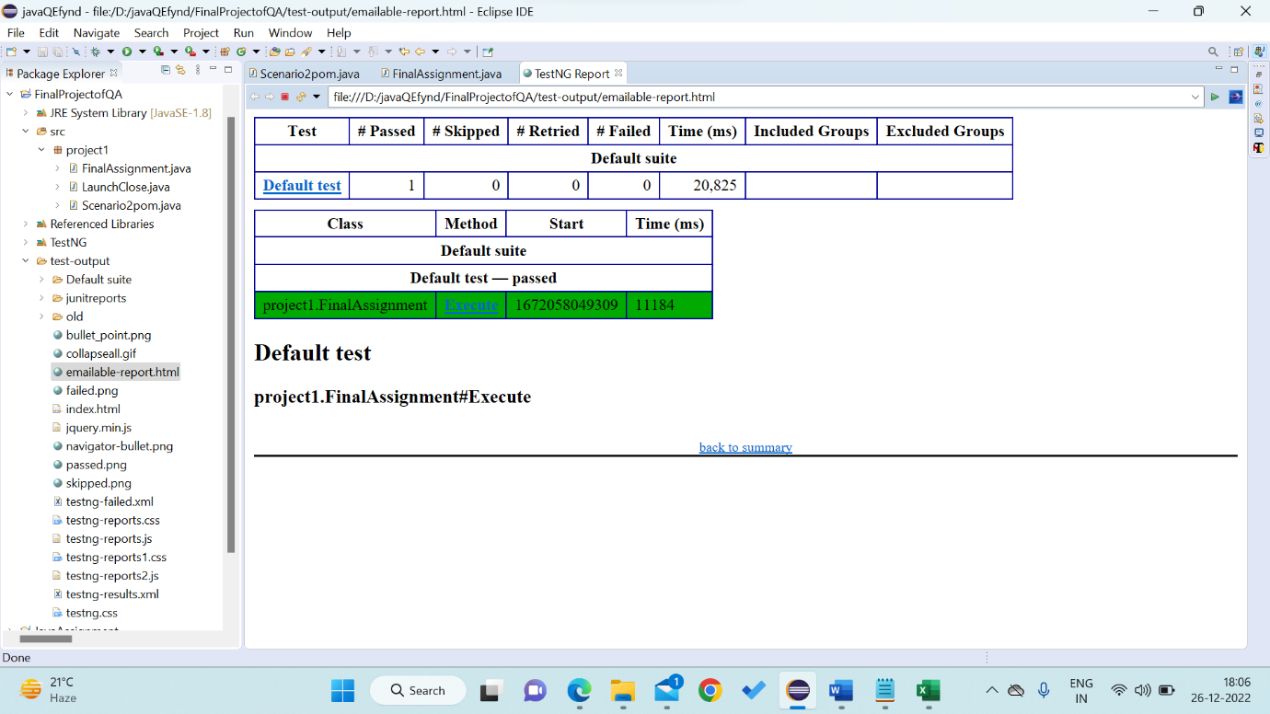

**Links are successfully stored in Web.xlsx**

